Maths assignment

1CWK50

Pritam Sangani

16039231

Table of Contents

Question 1 2

Question 1: Answer 2

Question 2 4

Question 2: Answer 4

Question 3 6

Question 3: Answer 6

Question 4 8

Question 4: Answer 8

Question 5 10

Question 5: Answer 10

Question 6 13

Question 6: Answer 13

Question 7 15

Question 7: Answer 15

# Question 1

Given that *U* = {1, 2, 3,…,10} is the universal set, *A* = { $x$: $x$ $∈$ $N$, $x$ is an odd number}  
*B* = { $x$: $x$ $∈$ $N$, $x$ is a square number} and *C* = { $x$: $x$ $∈$ $N$, $2≤x<5$}, find the following:

1. |*A*|, |*A $∩$ B*|, |*C*|; **[4]**
2. *P(B)*;**[3]**
3. C’, *B* x *C*, *A $∩$*  *C*, *C* \ *B*. **[8]**

**[15 marks for this question]**

## Question 1: Answer

*U* = {1, 2, 3,…, 10}  
*A* = { $x$: $x$ $∈$ $N$, $x$ is an odd number}  
*B* = { $x$: $x$ $∈$ $N$, $x$ is a square number}  
*C* = { : , }

1. **|*A*|:**

Set A = {1, 3, 5, 7, 9}

**|*A*| = 5**

**|*A $∩$ B*|:**

Set A = {1, 3, 5, 7, 9}

Set B = {1, 4, 9}

*A $∩$ B* = {1, 9}

**|*A $∩$ B*| = 2**

**|*C*|:**

Set C = {2, 3, 4}

**|*C*| = 3**

1. ***P(B)*:**

Set B = {1, 4, 9}

$∴$***P(B)* = { $∅$, {1}, {4}, {9}, {1, 4}, {1, 9}, {4, 9}, {1, 4, 9} }**

1. **C’:**

*U* = {1, 2, 3, 4, 5, 6, 7, 8, 9, 10}

Set C = {2, 3, 4}

$∴$***C’* = {1, 5, 6, 7, 8, 9, 10}**

***B* x *C*:**

Set B = {1, 4, 9}

Set C = {2, 3, 4}

$∴$***B* x *C* = { (1, 2), (1, 3), (1, 4), (4, 2), (4, 3), (4, 4), (9, 2), (9, 3), (9, 4) }**

***A $∩$*  *C*:**

Set A = {1, 3, 5, 7, 9}

Set C = {2, 3, 4}

$∴$***A $∩$*  *C* = {3}**

***C* \ *B*:**

Set C = {2, 3, 4}

Set B = {1, 4, 9}

$∴$***C* \ *B* = {2, 3}**

# Question 2

1. Draw a Venn diagram to represent the following sets: **[6]**

*U* = { $x$: $x$ $∈$ $N$, $x ≤$ 36}

*F* = { $x$: $x$ $∈$ $N$, $x$ is a prime number, $0 ≤x ≤15$}

*G* = { $x$: $x$ $∈$ $N$, $x$ is a multiple of 3, $0 ≤x ≤20$}

*H* = { $x$: $x$ $∈$ $N$, $x$ is a factor of 36}

1. Use a Venn diagram to illustrate the following: **[4]**
   1. (*A $∩$ B*) $∩$ C’
   2. (*B $∪$ C*) \ *A’*

**[10 marks for this question]**

## Question 2: Answer

1. *U* = { $x$: $x$ $∈$ $N$, $x ≤$ 36}

*F* = {2, 3, 5, 7, 11, 13}

*G* = {3, 6, 9, 12, 15, 18}

*H* = {1, 2, 3, 4, 6, 9, 12, 18, 36}

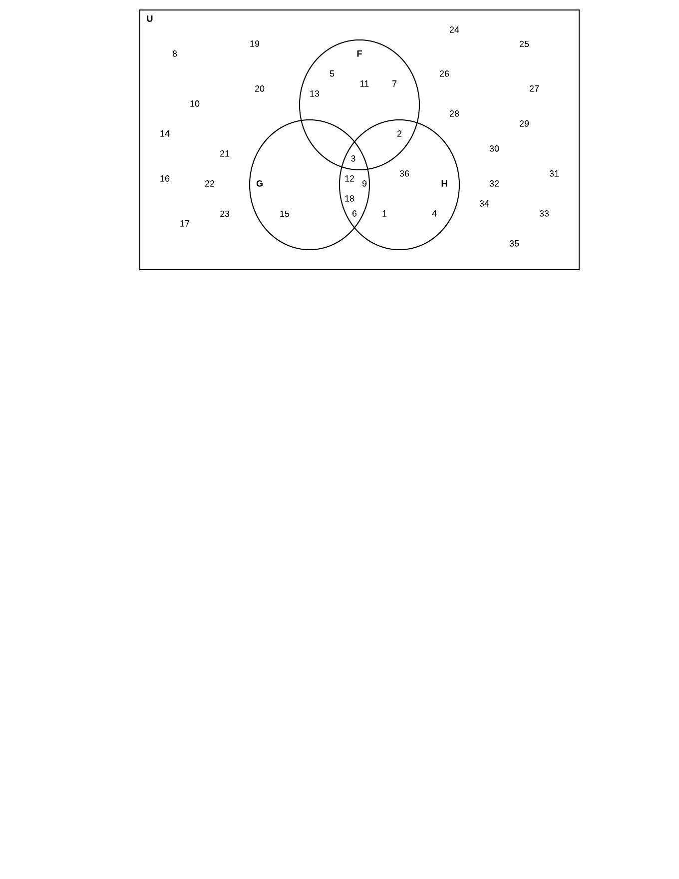

1. (*A $∩$ B*) $∩$ C’:

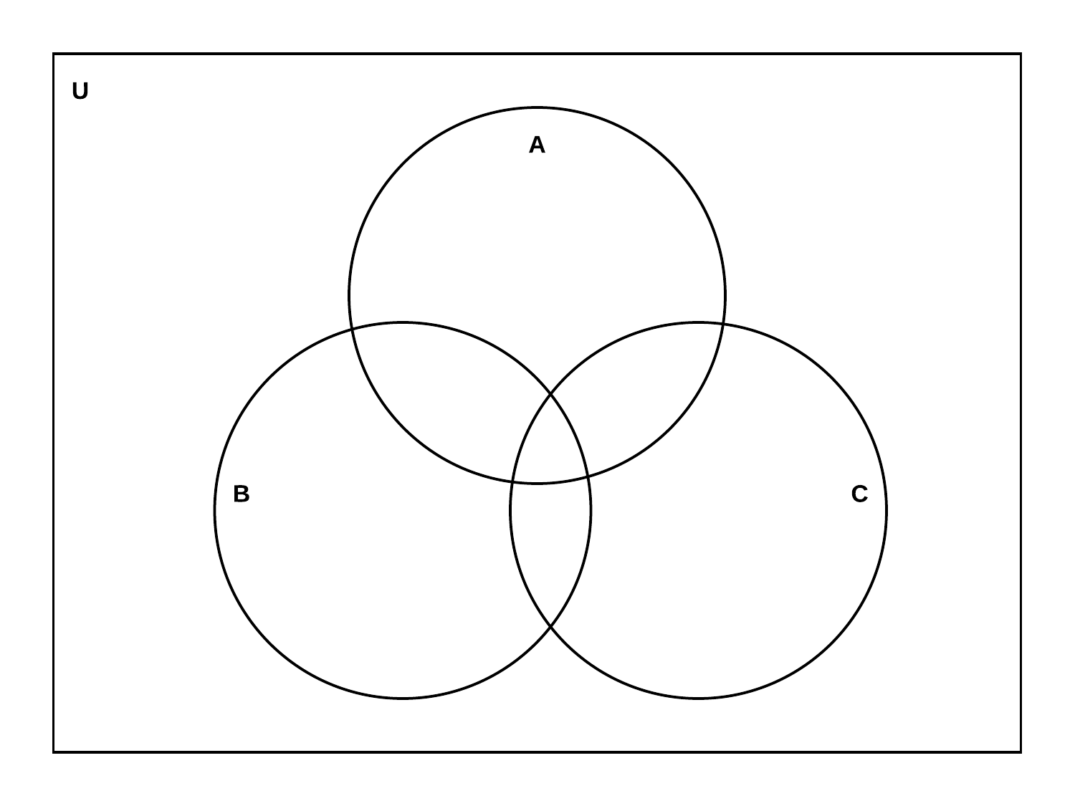

1. (*B $∪$ C*) \ *A’*:



# Question 3

For the three vectors, **a** = 2 $\hat{i}$– 3 $\hat{j}$– $\hat{k}$, **b** = $\hat{i}$– 2 $\hat{j}$– $\hat{k}$ and **c** = $\hat{i}$– $\hat{j}$– $\hat{k}$:

1. calculate **a** + 2**c [3]**
2. the unit vector in the direction of **c [3]**
3. calculate **a**.**c** and find the angle between the two vectors **[5]**
4. calculate **a** x **b [4]**

**[15 marks for this question]**

## Question 3: Answer

**a** = 2 $\hat{i}$– 3 $\hat{j}$– $\hat{k}$  
**b** = $\hat{i}$– 2 $\hat{j}$– $\hat{k}$  
**c** = $\hat{i}$– $\hat{j}$– $\hat{k}$

1. **a** + 2**c :**

**a** = 2 $\hat{i}$– 3 $\hat{j}$– $\hat{k}$

**c** = $\hat{i}$– $\hat{j}$– $\hat{k}$

2**c** = 2( $\hat{i}$– $\hat{j}$– $\hat{k}$)  
 = 2 $\hat{i}$– 2 $\hat{j}$– 2 $\hat{k}$

**a** + 2**c** = (2 $\hat{i}$– 3 $\hat{j}$– $\hat{k}$) + (2 $\hat{i}$– 2 $\hat{j}$– 2 $\hat{k}$)

$∴$**a** + 2**c** = 4 $\hat{i}$– 5 $\hat{j}$– 3 $\hat{k}$

1. **c** = $\hat{i}$– $\hat{j}$– $\hat{k}$

$$\hat{c}=\frac{c}{\left||c\right||}$$

$\left||c\right||= \sqrt{1^{2}+ {(-1)}^{2}+{(-1)}^{2}}$ = $\sqrt{3}$

$$\hat{c}=\frac{\hat{i} – \hat{j} – \hat{k}}{\sqrt{3}}$$

$∴$ $\hat{c}= \frac{1}{\sqrt{3}} \hat{i}- \frac{1}{\sqrt{3}} \hat{j}- \frac{1}{\sqrt{3}} \hat{k}$

1. **a** = 2 $\hat{i}$– 3 $\hat{j}$– $\hat{k}$

**c** = $\hat{i}$– $\hat{j}$– $\hat{k}$

$$\cos{θ}=\frac{a . c}{\left|\left|a\right|\right| |\left|c\right||}$$

**a** . **c** =(2 $\hat{i}$– 3 $\hat{j}$– $\hat{k}$) . ( $\hat{i}$– $\hat{j}$– $\hat{k}$)

= (2 x 1) + (-3 x -1) + (-1 x -1)

= (2) + (3) + (1)

$∴$**a .** **c** = 6

||**a**|| =

=

||**a**|| =

||**c**|| =

=

||**c**|| =

= (to 3sf)

1. **a** = 2 $\hat{i}$– 3 $\hat{j}$– $\hat{k}$  
   **b** = $\hat{i}$– 2 $\hat{j}$– $\hat{k}$

**a** x **b** = $\left(a_{2}b_{3}- a_{3}b_{2}\right)\hat{i}+\left(a_{3}b_{1}- a_{1}b_{3}\right)\hat{j}+(a_{1}b_{2}- a_{2}b_{1})\hat{k}$

= ((-3 x -1) – (-1 x -2)) $\hat{i}$ + ((-1 x 1) – (2 x -1)) $\hat{j}$ + ((2 x -2) – (-3 x 1) $\hat{k}$

= (3 – 2) $\hat{i}$ + (-1 + 2) $\hat{j}$ + (-4 + 3) $\hat{k}$

$∴$**a** x **b** = $\hat{i}$ + $\hat{j}$- $\hat{k}$

# Question 4

In a computer game, a laser gun is fired from a point given by the position vector  
**q** = (10, -10, 20) in the direction given by **v** = (20, -30, 10). Calculate:

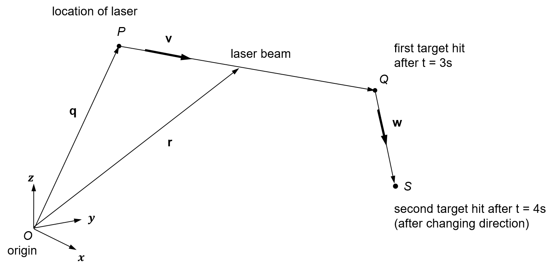

1. the coordinates of the point where the laser hits a target after time, t = 3 **[5]**
2. the total distance travelled by the laser, if the laser changes direction after hitting the first target along the vector **w** = (5, 10, 30) to hit another target after t = 4. **[5]**

**[10 marks for this question]**

## Question 4: Answer

1. **r** = **q** + **v**t

**r** = ?

**q** = (10, -10, 20)

**v** = (20, -30, 10)

t = 3

**r** = (10, -10, 20) + 3(20, -30, 10)

= (10, -10, 20) + (60, -90, 30)

$∴$**r** = (70, -100, 50)

1. **r** = **q** + **v**t

**r** = ?

**q** = (70, -100, 50)

**v** = (5, 10, 30)

t = 4

**r** = (70, -100, 50) + 4(5, 10, 30)

= (70, -100, 50) + (20, 40, 120)

$∴$**r** = (90, -60, 170)

Point P is at (10, -10, 20)

Point Q is at (70, -100, 50)

Point S is at (90, -60, 170)

$$d\left(Q-P\right)= \sqrt{{(70-10)}^{2}+ {(-100-\left(-10\right))}^{2}+ {(50-20)}^{2}}$$

= $\sqrt{{(60)}^{2}+ {(-90)}^{2}+ {(30)}^{2}}$

= $\sqrt{3600+ 8100+ 900}$

$∴$ $d\left(Q-P\right)=\sqrt{12600}$

$$d\left(S-Q\right)= \sqrt{{(90-70)}^{2}+ {(-60-\left(-100\right))}^{2}+ {(170-50)}^{2}}$$

= $\sqrt{{(20)}^{2}+ {(40)}^{2}+ {(120)}^{2}}$

= $\sqrt{400+ 1600+ 14400}$

$∴$ $d\left(S-Q\right)= \sqrt{16400}$

Total distance travelled (P to S) = $\sqrt{16400}+ \sqrt{12600}$

$∴$ Total distance travelled (P to S) = 240.31 (to 2dp)

# Question 5

You are given the following matrices:

*U* = $\left(\begin{matrix}1 & 3 & 1 \\ 0 & 2 & -1 \\ 3 & -2 & 5\end{matrix}\right)$*V* = $\left(\begin{matrix}-1 & 5 & 2 \\ 0 & 3 & 1\end{matrix}\right)$*W* = $\left(\begin{matrix}2 & -1 \\ 3 & 5\end{matrix}\right)$*Z* = $\left(\begin{matrix}3 & -2 & 0 \\ -1 & 4 & 2\end{matrix}\right)$

1. Write down matrix elements $u_{31}$, $u_{21}$, $v_{32}$, $v_{12}$, $w_{22}$ and $z_{33}$ if possible. Explain why if not possible.  **[6]**
2. Calculate the following if possible and explain why if not possible:
3. *V* + *W*  **[2]**
4. *V* – *Z* **[3]**
5. *UVT* **[6]**
6. *WZ* **[4]**
7. If a point (3, 1) is reflected about the line y= $\left(tanθ\right)x$ with $θ=120°$, find the reflection line and the reflection point. **[4]**

**[25 marks for this question]**

## Question 5: Answer

*U* = $\left(\begin{matrix}1 & 3 & 1 \\ 0 & 2 & -1 \\ 3 & -2 & 5\end{matrix}\right)$*V* = $\left(\begin{matrix}-1 & 5 & 2 \\ 0 & 3 & 1\end{matrix}\right)$*W* = $\left(\begin{matrix}2 & -1 \\ 3 & 5\end{matrix}\right)$*Z* = $\left(\begin{matrix}3 & -2 & 0 \\ -1 & 4 & 2\end{matrix}\right)$

1. $u_{31}$ = 3

$u_{21}$ = 0

$v_{32}$: not possible as matrix V only has 2 rows

$v_{12}$ = 5

$w_{22}$ = 5

$z_{33}$: not possible as matrix Z only has 2 rows

1. *V* + *W* :

*V* + *W $=$ $\left(\begin{matrix}-1 & 5 & 2 \\ 0 & 3 & 1\end{matrix}\right)$* 󠇔 + $\left(\begin{matrix}2 & -1 \\ 3 & 5\end{matrix}\right)$

**Not possible** as matrix V has 2 rows and 3 columns, whereas, matrix W has 2 rows and 2 columns

$∴$ matrices V and W are not the same size so matrix addition cannot be done

1. *V* – *Z* :

*V* – *Z $=$ $\left(\begin{matrix}-1 & 5 & 2 \\ 0 & 3 & 1\end{matrix}\right)$* - $\left(\begin{matrix}3 & -2 & 0 \\ -1 & 4 & 2\end{matrix}\right)$

$=$ $\left(\begin{matrix}(-1-3) & (5-\left(-2\right)) & (2-0) \\ (0-\left(-1\right)) & (3-4) & (1-2)\end{matrix}\right)$

*V* – *Z $=$ $\left(\begin{matrix}-4 & 7 & 2 \\ 1 & -1 & -1\end{matrix}\right)$*

1. *UVT*:

*VT* =

*UVT* =

=

=

*UVT* =

1. *WZ*:

*WZ* = $\left(\begin{matrix}2 & -1 \\ 3 & 5\end{matrix}\right)$ $\left(\begin{matrix}3 & -2 & 0 \\ -1 & 4 & 2\end{matrix}\right)$

= $\left(\begin{matrix}(\left(2x3\right)+\left(-1x-1\right)) & (\left(2x-2\right)+\left(-1x4\right)) & (\left(2x0\right)+\left(-1x2\right)) \\ (\left(3x3\right)+\left(5x-1\right)) & (\left(3x-2\right)+\left(5x4\right)) & (\left(3x0\right)+\left(5x2\right))\end{matrix}\right)$

= $\left(\begin{matrix}(6+1) & (-4-4) & (0-2) \\ (9-5) & (-6+20) & (0+10)\end{matrix}\right)$

$∴$*WZ* = $\left(\begin{matrix}7 & -8 & -2 \\ 4 & 14 & 10\end{matrix}\right)$

1. point (3, 1) is reflected about y= $\left(tanθ\right)x$ $θ=120°$

$$\left(\begin{matrix}\cos{2θ} & \sin{2θ} \\ \sin{2θ} & -cos{2θ}\end{matrix}\right)$$

$θ=120°$, $\tan{120}= -\sqrt{3}$

$∴$ line of reflection: $y=-\sqrt{3}x$

$$\left(\begin{matrix}\cos{2(120)} & \sin{2(120)} \\ \sin{2(120)} & -cos{2(120)}\end{matrix}\right)$$

$≡$ $\left(\begin{matrix}\cos{240} & \sin{240} \\ \sin{240} & -cos{240}\end{matrix}\right)$

$$≡\left(\begin{matrix}-\frac{1}{2} & -\frac{\sqrt{3}}{2} \\ -\frac{\sqrt{3}}{2} & \frac{1}{2}\end{matrix}\right)$$

$$\left(\begin{matrix}3 & 1\end{matrix}\right)\left(\begin{matrix}-\frac{1}{2} & -\frac{\sqrt{3}}{2} \\ -\frac{\sqrt{3}}{2} & \frac{1}{2}\end{matrix}\right)$$

$$≡\left(\begin{matrix}\left(-\frac{1}{2} x 3\right)+\left(-\frac{\sqrt{3}}{2} x 1\right) & \left(-\frac{\sqrt{3}}{2} x 3\right)+\left(\frac{1}{2} x 1\right)\end{matrix}\right)$$

$$≡\left(\begin{matrix}\left(-\frac{3}{2} \right)+\left(-\frac{\sqrt{3}}{2} \right) & \left(-\frac{3\sqrt{3}}{2} \right)+\left(\frac{1}{2} \right)\end{matrix}\right)$$

$$≡\left(\begin{matrix}-\frac{3+\sqrt{3}}{2} & \frac{1-3\sqrt{3}}{2}\end{matrix}\right)$$

$∴$ point of reflection: $\left(-\frac{3+\sqrt{3}}{2},\frac{1-3\sqrt{3}}{2}\right)$

# Question 6

For the three functions, $h :R →R, h\left(x\right)=2x-1$, $u :R →R, u\left(x\right)= \frac{x}{2}-1$ and $v :R →R, v\left(x\right)=x^{2}+3$ 
, where *R* is the set of the real numbers:

1. Write down the composite functions $v o h$, $v o u$; **[5]**
2. Find the values of the composite function, $v o h$, for $x= -1, 0, 2$. **[5]**

**[10 marks for this question]**

## Question 6: Answer

1. $v o h$:

$$v o h ≡vh(x)$$

$$v\left(x\right)=x^{2}+3$$

$$h\left(x\right)=2x-1$$

$∴$ $vh\left(x\right)$ = ${(2x-1)}^{2}+3$ $≡$ ${(4x}^{2}-4x+1)+3$

$≡{(4x}^{2}-4x+4)$

$≡$ $4{(x}^{2}-x+1)$

$v o u$:

$v o u$ $≡$ $vu(x)$

$$v\left(x\right)=x^{2}+3$$

$$u\left(x\right)= \frac{x}{2}-1$$

$vu\left(x\right)= {\left(\frac{x}{2}-1\right)}^{2}+3$

$x= -1, 0, 2$

$v o h$ $≡$ $vh\left(x\right)$ = $4{(x}^{2}-x+1)$

when $x= -1$:

$vh\left(x\right)$ = $4{((-1)}^{2}-(-1)+1)$

= 4(1+1+1)

$∴$ $vh\left(x\right)$ = 12

when $x=0$:

$vh\left(x\right)$ = $4{((0)}^{2}-(0)+1)$

= $4\left(0-0+1\right)$

$∴$ $vh\left(x\right)$ = 4

when $x=2$:

$vh\left(x\right)$ = $4{((2)}^{2}-(2)+1)$

= $4\left(4-2+1\right)$

$∴$ $vh\left(x\right)$ = 12

# Question 7

Given the relation below, defined on $R →R$, where *R* is the set of the real numbers:

$$b\left(x\right)= \frac{2(x+1)}{x-1}$$

1. Explain when *b* is a function and write down the three values of $b(x)$, for $x=0, 2, 3$ 
   , using the ordered pair representation; **[5]**
2. if the relation is a function, state whether it is a total or partial function and classify it as an injection, surjection, bijection or a combination of these; **[4]**
3. find the inverse function $b^{-1} :R →R$ and determine the domain and the range that make the relation a function; **[4]**
4. explain why the values $b(1)$ and $b^{-1}(2)$ are not valid for these functions. **[2]**

**[15 marks for this question]**

**[Total: 100 marks]**

## Question 7: Answer

1. b is a function when $x ϵ R, x≠1$

$$b\left(x\right)= \frac{2(x+1)}{x-1}$$

$$x=0, 2, 3$$

when $x=0$:

$$b\left(x\right)= \frac{2(0+1)}{0-1}= \frac{2}{-1}$$

$∴$ when $x=0$, $b\left(x\right)= -2$

when $x=2$:

$$b\left(x\right)= \frac{2(2+1)}{2-1}= \frac{6}{1}$$

$∴$ when $x=2$, $b\left(x\right)= 6$

when $x=3$:

$$b\left(x\right)= \frac{2(3+1)}{3-1}= \frac{8}{2}$$

$∴$ when $x=2$, $b\left(x\right)= 4$

ordered pair representation:

{(0, -2), (2, 6), (3, 4)}

1. b is a partial injection
2. $b^{-1}\left(x\right)$:

$$b\left(x\right)= \frac{2(x+1)}{x-1}$$

$$b\left(x\right)≡y$$

$$y= \frac{2\left(x+1\right)}{x-1}$$

$$x= \frac{2(y+1)}{y-1}$$

$$≡x\left(y-1\right)=2(y+1)$$

$$≡xy-x=2y+2$$

$$≡xy-2y=x+2$$

$$≡y\left(x-2\right)=x+2$$

$$y= \frac{x+2}{x-2}$$

$$∴{ b}^{-1}\left(x\right)= \frac{x+2}{x-2}$$

domain: $x ϵ R, x≠2$

range: $b^{-1}\left(x\right) ϵ R, b^{-1}\left(x\right)≠1$

1. is not possible as $b\left(x\right)= \frac{4}{0}$ when $x$ = 1. $b\left(x\right)$ cannot tend to infinity.

$b^{-1}\left(2\right)$ is not possible as $b^{-1}\left(x\right)= \frac{4}{0}$ when $x=2$. $b^{-1}\left(x\right)$ cannot tend to infinity.